**Automation Testing with Cucumber in KATALON**

*What is Cucumber?*

Cucumber is a tool that supports Behavior Driven Development (BDD). It offers a way to write tests that anybody can understand, regardless of their technical knowledge.

*How does it work?*

- Cucumber reads the code written in plain English text (Language Gherkin) in **the** **feature file**.

- Then it finds the exact match of each step in **the step definition** (a code file - details provided later in the tutorial).

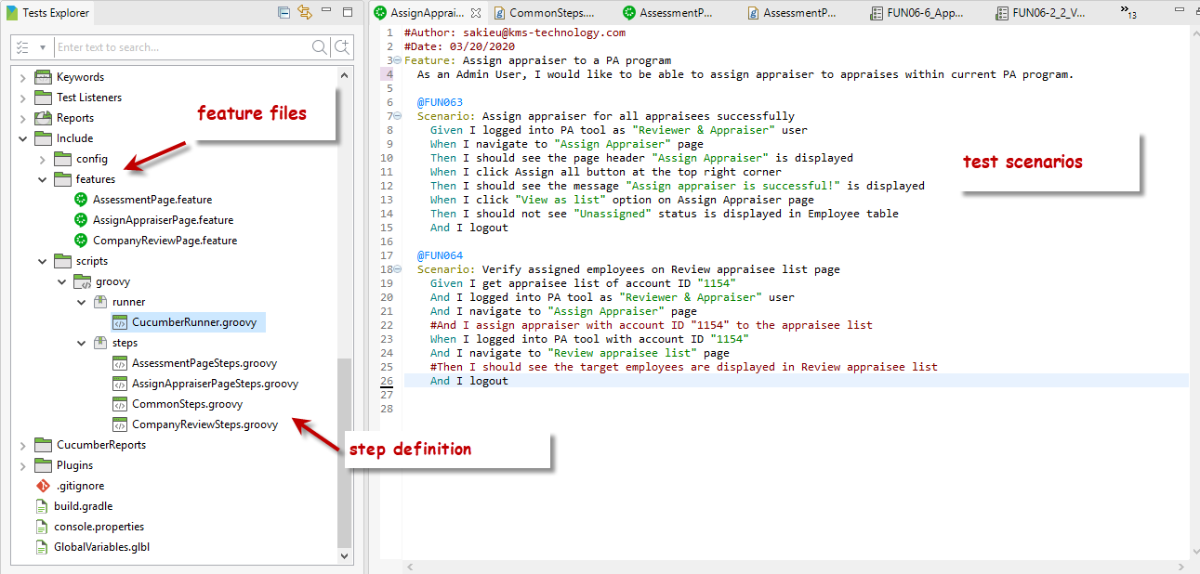

**HOW TO**

1. Create test scenarios for corresponding feature

· **Feature** − Name of the feature under test.

· **Description** (optional) − Describe about feature under test.

· **Scenario** − What is the test scenario.

· **Given** – Define the precondition.

· **When** – Define the action we need to perform.

· **Then** – Define the expected outcome or result.

- Features are currently structured by page – change as need

- Test case ID should be added above each test scenarios as tag (ex: @FUN01)

- ‘Then’ step should be started with pattern “I should…” so that we can distinguish with other action steps

- CTRL + Spacebar to show matching steps before defining new step to avoid creating duplicated test steps

2. Write step definition for each test step

-

3. Run with Cucumber Runner :<https://docs.katalon.com/katalon-studio/docs/cucumber-features-file.html#in-test-cases>